**El Espada**

**Installation Instructions**

**Prepared by the Avengers – UIS Force:**

**Avinash Moram**

**Daniel Henderson**

**Zach Parker**

TABLE OF CONTENTS

Installation Instructions Documentation 3

System Requirements 4

Installation Instructions 5

Accessing the Website 6

Any Known Issues 7

Source Code for Developers 7

Troubleshooting 8

Java Installation Document 11

**Installation Instructions Documentation**

**System Requirements**

The application needs the following system pre-requisites for the El Espada Online Ordering System to install and work properly

* Windows 10, 64-bit operating system (PC or laptop)
* Java JDK 8u251 (**Refer Java Installation document**)
* Spring Tool Suite 4 (Developers)
* Maven (any latest version, Developers)
* Chrome browser
* Have a keyboard and mouse for navigating through the website
* Any archive unzipper tool
* Admin rights for the user that is installing

**Installation Instructions**

**Download and extract the below zip file that has the installer**

<https://github.com/zkparker/Software-Engineering-Capstone/blob/master/el-espada/installer/el-espada_v4.jar>

1. **You will see a el-espada_v4.jar file in the extracted folder, please copy it to desktop preferably or any other folder where you have admin access**



1. **Double click the el-espada_v4.jar**
2. **To verify if the application is successfully installed, please open Task Manager by pressing the keys Ctrl+Shift+Esc or right click on windows task bar at the bottom right corner where time is displayed and select Task Manager, you will see a Java(TM) Platform SE binary process**

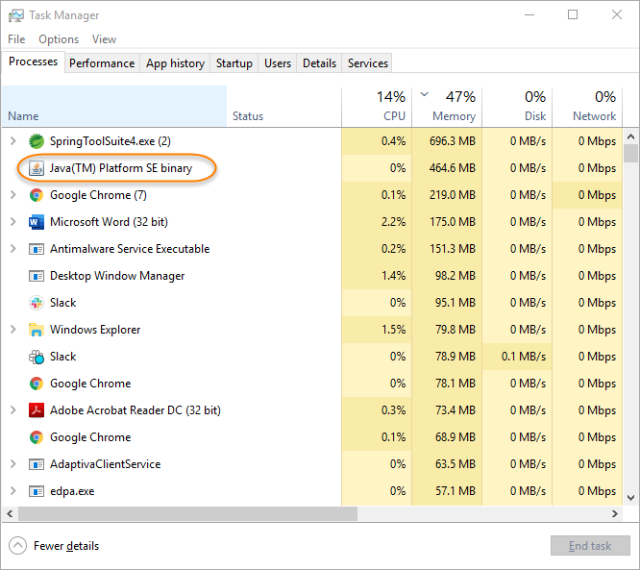

1. **Other way is to open the logs folder where you have double clicked the el-espada_v4.jar, you will see elespada.log file. Open the file in notepad or any text editor, search for “Tomcat started on port(s): 9090”**
2. **You have successfully installed the application**

**Accessing the website**

**Open chrome browser and type** <http://localhost:9090> **into the address bar and hit enter key on your keyboard, you should see the below home page where you can see menu items for starting your order**

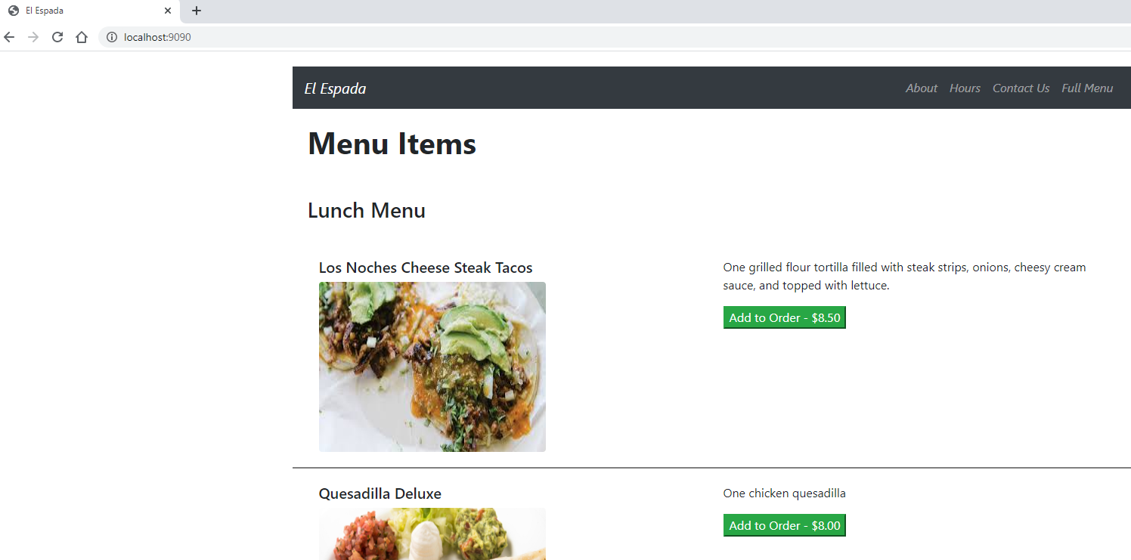

**Any knows issues that might affect installation or use**

**Port is in use or the latest JDK is not installed. Please see troubleshooting section below for details on both.**

**Source Code for Developers**

**All source code can be found at the following GitHub repository:**

<https://github.com/zkparker/Software-Engineering-Capstone>

**Troubleshooting**

* **When accessing the website on** <http://localhost:9090> **is ending in 404 or website not accessible, check the logs folder.**
* **The logs folder is located at the same place where you have copied the el-espada_v4.jar and double clicked it.**
* **Search for the word ERROR, below that you will see the reason why the application failed to start; if it is one of the below, please follow the steps to resolve**

**Port 9090 was already in use**

***\*\*\*\*\*\*\*\*\*\*\*\*\*\*\*\*\*\*\*\*\*\*\*\*\*\*\****

***APPLICATION FAILED TO START***

***\*\*\*\*\*\*\*\*\*\*\*\*\*\*\*\*\*\*\*\*\*\*\*\*\*\*\****

***Description:***

***Web server failed to start. Port 9090 was already in use.***

***Action:***

***Identify and stop the process that's listening on port 9090 or configure this application to listen on another port.***

**Solution: Open command prompt, type the command *netstat -ano*, you will see all the processes running on the machine. The Local Address will have the port number after the colon “:”, look for its PID (process id and note it down)**

**Then run the below command to stop that other process running on port 9090 by running the command task *taskkill /F /PID <process id>***

**Example**:

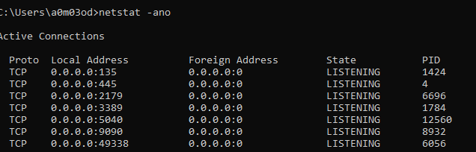

**In the above image, we can see that port 9090 is already in use by PID 8932**

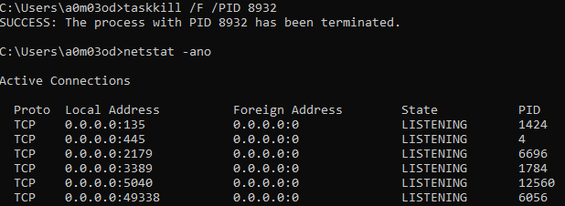

**After executing taskkill command, you can see the success message that the PID has been terminated**

**Failed to bind properties under 'spring.datasource.password' to java.lang.String:**

***\*\*\*\*\*\*\*\*\*\*\*\*\*\*\*\*\*\*\*\*\*\*\*\*\*\*\****

***APPLICATION FAILED TO START***

***\*\*\*\*\*\*\*\*\*\*\*\*\*\*\*\*\*\*\*\*\*\*\*\*\*\*\****

***Description:***

***Failed to bind properties under 'spring.datasource.password' to java.lang.String:***

***Reason: Encryption raised an exception. A possible cause is you are using strong encryption algorithms and you have not installed the Java Cryptography Extension (JCE) Unlimited Strength Jurisdiction Policy Files in this Java Virtual Machine***

***Action:***

***Update your application's configuration***

**Solution: You do not have the latest JDK 8 on your machine that supports Java Cryptography Extension, please install JDK 8u251 version from** [here](https://www.oracle.com/java/technologies/javase/javase-jdk8-downloads.html)

**Failed to bind properties under 'spring.datasource.password' to java.lang.String:**

***\*\*\*\*\*\*\*\*\*\*\*\*\*\*\*\*\*\*\*\*\*\*\*\*\*\*\****

***APPLICATION FAILED TO START***

***\*\*\*\*\*\*\*\*\*\*\*\*\*\*\*\*\*\*\*\*\*\*\*\*\*\*\****

***Description:***

***Failed to bind properties under 'spring.datasource.password' to java.lang.String:***

***Reason: Failed to bind properties under 'spring.datasource.password' to java.lang.String***

***Action:***

***Update your application's configuration***

**Solution: You do not have the latest JDK 8 on your machine that supports Java Cryptography Extension, please install JDK 8u251 version from** [here](https://www.oracle.com/java/technologies/javase/javase-jdk8-downloads.html)

**How to stop the el-espada_v4.jar**

**We can stop the application two ways.**

1. **First is through command prompt, no risk using this way**

* **Open command prompt, type the command *jps*, you will see all the process id where el-espada_v4.jar is running**
* **Then run the below command to stop that process id by running the command task *taskkill /F /PID <process id>***

**Example:**

**el-espada_v4.jar is running on process 3336**

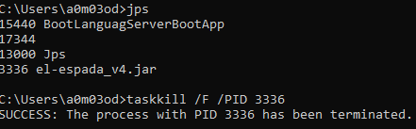

1. **Second is through task manager, risk is you may terminate another process that is running on java. The website is run as an independent java process. If you see the below screenshot there are two java processes running. We need to stop the one that is highlighted.**

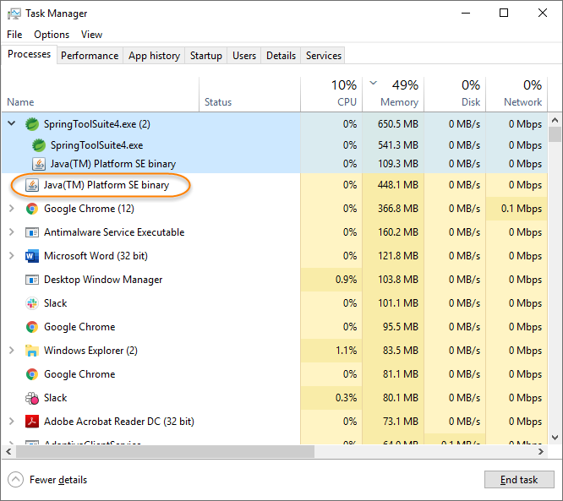

**Problem running jps command:**

**If you see “jps” is not recognized as an internal or external command, then jdk bin is not set in the environments variable PATH. Refer Java Installation document on how to set the java in environment variables.**

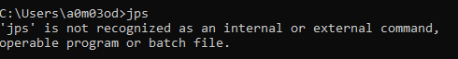

**Java Installation Document**

Please refer to the Java Installation Document if no JDK is installed on your machine.

*Java Installation.docx*